# Problem 3 – IT Village

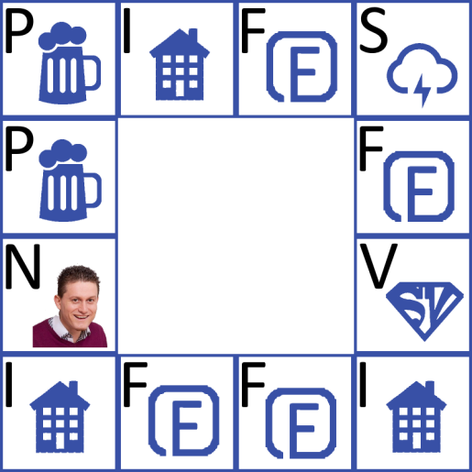Every Friday night a group of super cool programmers get together and play their favorite board game – "IT Village". But they are so tired of coding through the week so they forget the rules of the game all the time. Also they find it very difficult to work with paper and roll the dice so they made a very important decision – their game needed to evolve from board game into computer game. It is wide known fact that programmers are lazy. They started programming the game, but they stopped. Your task is to finish the game for them.

You are given a **game board** which is **4 fields high** and **4 fields wide**. You can play **only on the game fields** (first and the last row, as well as the first and the last column). All the **other fields** are always **empty** and you cannot play on them. You **start** the game on an **entering position** (on one of the game fields) and you **roll the dice**. You move on the game fields **clockwise**. You have the following **type of fields**:

|  |  |  |  |  |
| --- | --- | --- | --- | --- |
| **Field Name** | **Letter in the Input** | **Description** | **Money Gain(+) / Loose(-)** | **Occurrences in the Game** |
| Wi-Fi pub | P | You have to buy one Cloud Cocktail | -5 coins | Many |
| Wi-Fi Inn | I | 1. If you have enough money you have to buy the Inn 2. If you don't – you pay for you stay | 1. -100 coins 2. -10 coins | Many |
| Freelance Project | F | You get paid | 20 coins | Many |
| Storm | S | The Wi-Fi in the village dies and you get so depressed that you miss 2 moves | - | Many |
| Super Vlado | V | Your coins are multiplied by 10 | *10 | Only 1 field |
| Nakov | N | When you step on this field you immediately win the game | - | 1 or no such field |
| Entering Position | - | The field where you start the game | - | Only one field |
| Empty Field | 0 | Empty field | - | Always 4 |

You **start** **the game** with **50 coins**. For every **inn you own**, you gain **20 coins per inn per move**. When you **skip moves** because of a **storm** you **do not get paid** for inns as well. The **coins for inns** are added to your money in the **beginning of every move** (from the **next** one you bought the inn).

The **game ends** in the following cases:

|  |  |
| --- | --- |
| **Game End Case** | **Output** |
| If you run out of money (<= 0coins) | <p>You lost! You ran out of money!<p> |
| If you buy all the inns | <p>You won! You own the village now! You have {0} coins!<p> |
| If you run out of moves | <p>You lost! No more moves! You have {0} coins!<p> |
| If you step on "Nakov" field | <p>You won! Nakov's force was with you!<p> |

***Note:*** **{0}** is how much **coins you have** when the **game ends**.

### Input

The input will be read from an **HTTP GET** **request**. The **game board** will be received as a string from a **text** **input field with name 'board'**. The **entering position** will be received from a **text input field with name 'beginning'.** The numbers from **the dice** for each move will be received from a **text input field with name 'moves'**.

### Output

The output consists of a **paragraph**, containing **one of the messages** in the **'Output' column** in the table above.

### Constraints

* The **game board** will always be 4 fields wide and 4 fields high. The **string** for the game board **contains** the letter combinations: **P, I, F, S, V, N, EP** or **0**. The letter **N is optional**. All the other letters will always be in the game board. The **letter combinations** are separated by a **space**. The **rows** are separated by a **' | '**.
* The **entering position** will consist of **two numbers**, separated by a **space**. The first number is the row number, the second – the column number. For example **'3 4'** means that the entering position is **row 3**, **column 4**.
* The **dice numbers** are received as a **string of numbers from 2 to 12**, separated by a **space**.

### Examples

|  |  |  |
| --- | --- | --- |
| **Input** | | **Output** |
| board | P I F S | P 0 0 F | N 0 0 V | I F F I | <p>You lost! No more moves! You have 500 coins!<p> |
| **beginning** | 2 1 |
| moves | 5 11 9 8 6 8 4 |
| **Comment** | | |
| You start on row 2, column 1 – "P". First move is 5 – you go to "F" – you are paid 20 coins, you have 70 coins now. Second move is 11 – you go to "S" – you miss the next two moves – 9 and 8. Fifth move is 6 – you go to "I" – you have less than 100 coins so you pay 10 coins to sleep, you have 60 coins now. Sixth move is 8 – you go to "V" – Super Vlado multiplies your coins by 10 – you have 600 coins now. Seventh move is 4 – you go to "I" – you have enough coins so you buy it – you have 500 coins now. You have no more moves and you didn't buy all the inns, so the output is as shown on the left. | | |